Project Design Phase-II
Technology Stack (Architecture & Stack)

Date | 9 July 2026
Team ID
Project Name | ShopEZ
Maximum Marks | 4 Marks

Technical Architecture:
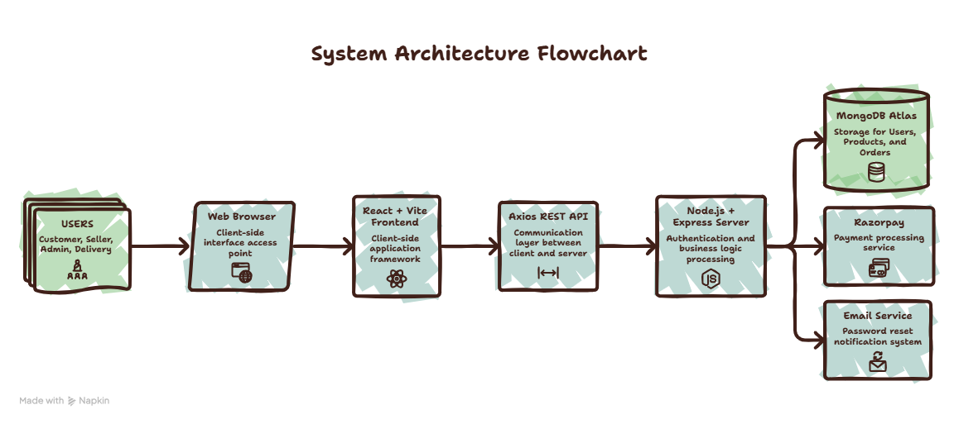

Table-1 : Components & Technologies:
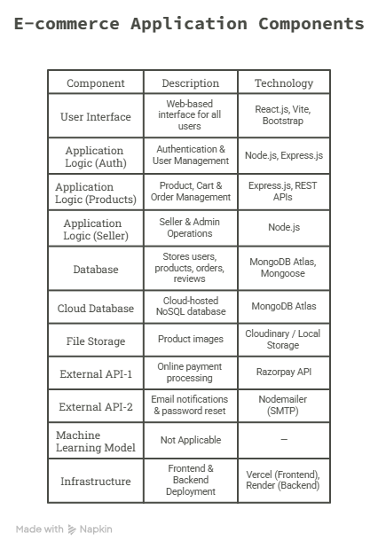

Table-2: Application Characteristics:

